Cyber Security: Lab 2

i) Netcraft

Identifying Phishing or legitimate site

**Netcraft: Comprehensive site information and protection from phishing and malicious JavaScript when browsing the web**

Go to -> <https://www.netcraft.com/>

Go to Browser and install Network Browser Extension for your browser

For Mozilla browser go here: <https://addons.mozilla.org/en-US/firefox/addon/netcraft-toolbar/?src=external-apps-download>

add the browser extension

Enter some website name in the url and Click on netcraft icon from the browser

It will show you the site information and the Risk rating.

Enter your Email ID and get the site report on your email ID

ii) Wapplyzer (Work with Chrome)

**wapplyzer- to test which technologies are used by the website developer. Add this to your browser extension**

<https://www.wappalyzer.com/>

Go to chrome extension, click wapplyzer extension and click it

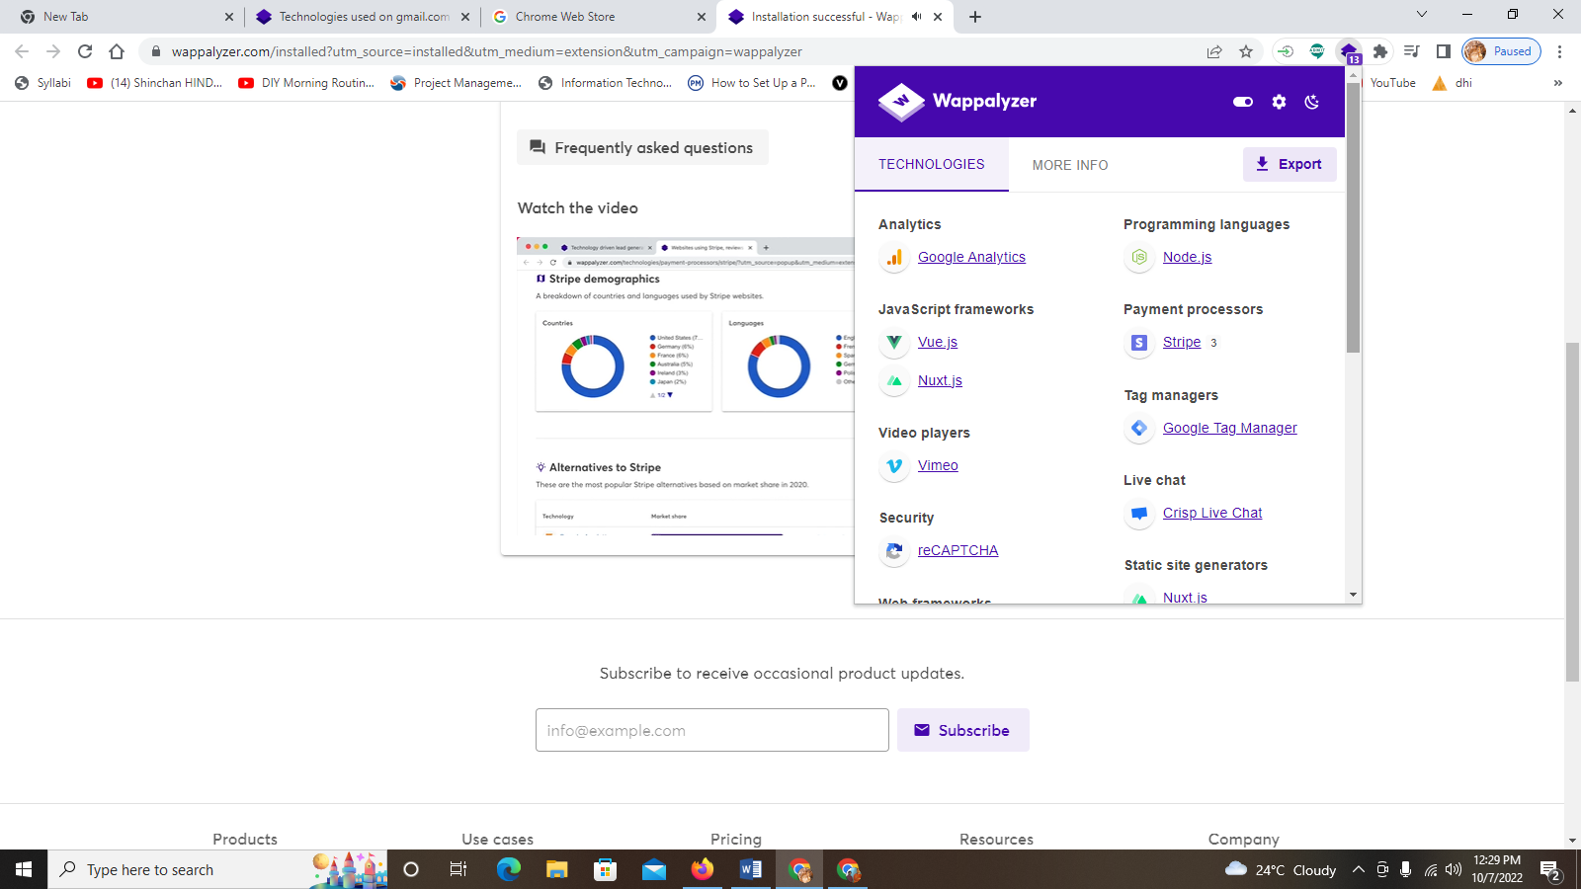

iii)Working with Kaali Linux: Installing Kaali Linux

Install Virtual box : <https://www.virtualbox.org/wiki/Downloads>

go to VirtualBox 7.0.2 platform packages

click on Windows hosts to download Virtual Box (simply download and keep)

Install Kaali linux

<https://www.kali.org/>

click on DOWNLOAD

Choose your Kaali Platform--> Click on Virtual Machines --> Click on VirtualBox and install kaali

Install Virtual box from the downloadable file

Extract Kaali folder from downloads

Open Virtaul box

Click on Machine --> ADD --> Select kaali linux -->click open --> select kali->run

username and password:Kali

kali linux will open

Click on terminal and execute the commands

Exercise: Work with basic commands with kaali linux

<https://mindmajix.com/linux-networking-commands-best-examples>

Execute all the commands from the above link and copy the outputs in the word file.